Question 1
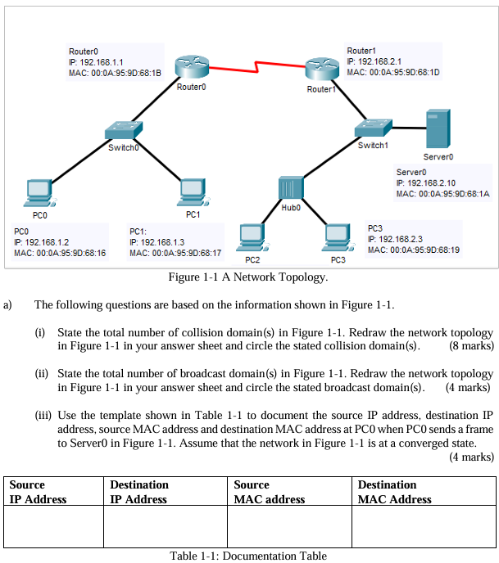
(i)
7 collision domains
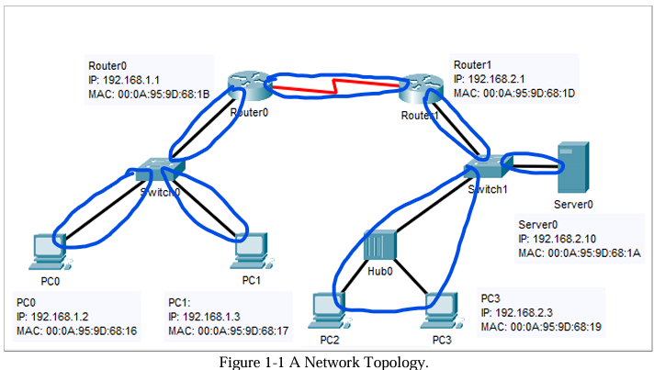

(ii)
3 broadcast domains
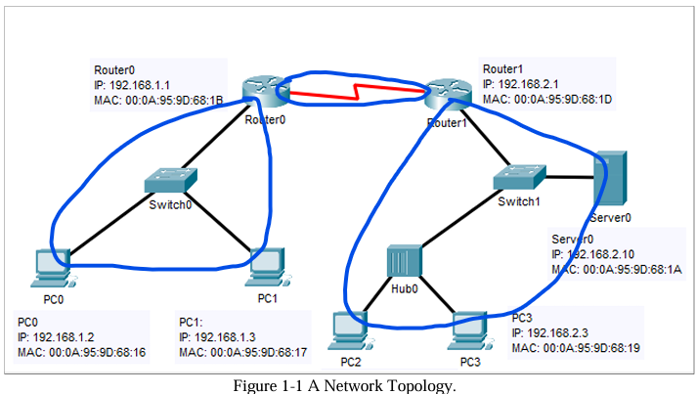

(iii)

Source IP Address | Destination IP Address | Source MAC Address | Destination MAC Address
192.168.1.2 | 192.168.2.10 | 00:0A:95:9D:68:16 | 00:0A:95:9D:68:1B

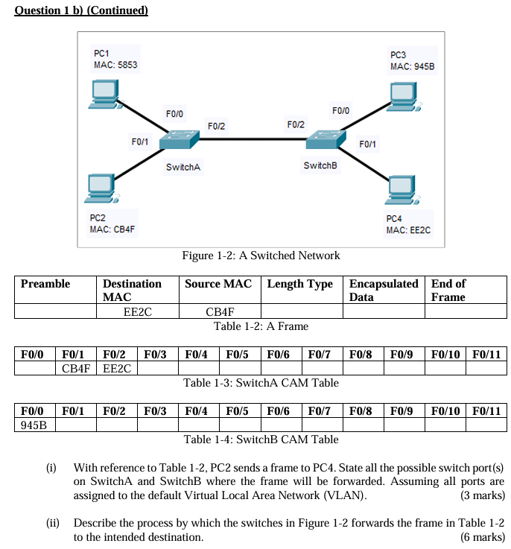
(i)
- Switch A: F0/2
- Switch B: F0/0, F0/1
(ii)
- When SwitchA receives the incoming frame, it will check whether the source MAC address of the frame CB4F is in the SwitchA CAM table. Since it exists at interface F0/1, it will reset the timeout settings back to 5 minutes.
- It will also check whether the destination MAC address of the frame EE2C matches or exists in the SwitchA CAM table.
- Since the destination MAC address of the frame has matched the MAC address recorded on port F0/2, SwitchA will forward the frame out of the port F0/2.
- When the frame reaches SwitchB, SwitchB will check whether the source MAC address of the frame CB4F is in the SwitchB CAM table. Since it does not exist, it will add the MAC address into the table.
- It will also check whether the destination MAC address of the frame EE2C exists in the SwitchB CAM table.
- Since the destination MAC is not in the SwitchB CAM table, SwitchB will flood the frame out all the active ports such as F0/0 and F0/1 except the ingress port F0/2.

Question 2

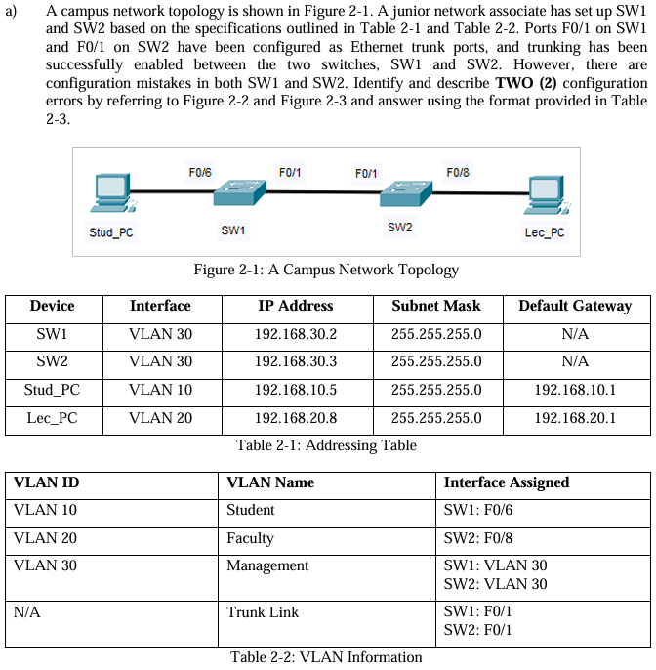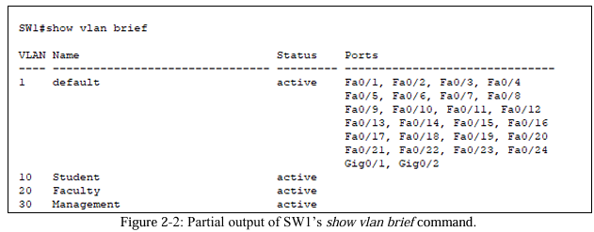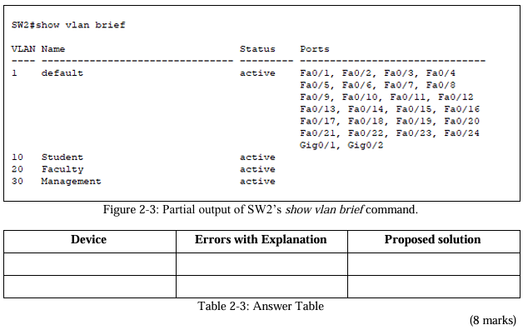
Device | Errors with Explanation | Propose solution
SW1 | The trunk port is configured wrongly since the interface F0/1 is still under VLAN 1. Meanwhile, the interface F0/6 should not be configured under VLAN 1. | The interface F0/1 should be set as the trunk interface and the interface F0/6 should be set as access mode and assigned into VLAN 10.  interface f0/1  switchport mode trunk  switchport trunk allowed vlan 10,30  interface f0/6  switchport mode access  switchport access vlan 10
SW2 | The trunk port is configured wrongly since the interface F0/1 is still under VLAN 1. Meanwhile, the interface F0/8 should not be configured under VLAN 1. | The interface F0/1 should be set as the trunk interface and the interface F0/8 should be set as access mode and assigned into VLAN 20.  interface f0/1  switchport mode trunk  switchport trunk allowed vlan 20,30  interface f0/8  switchport mode access  switchport access vlan 20

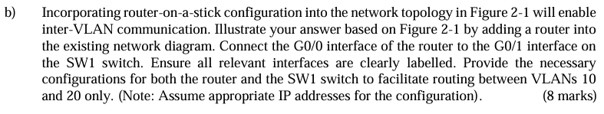
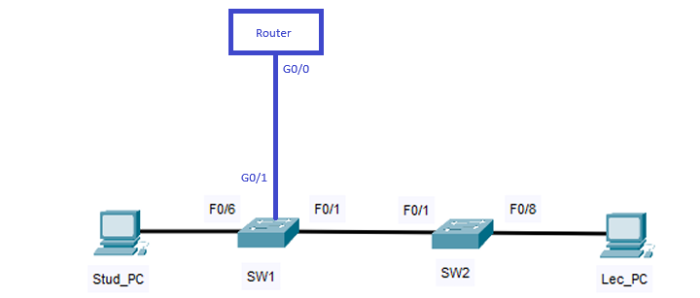
Router
interface g0/0.10
encapsulation dot1q 10
ip address 192.168.10.1 255.255.255.0

interface g0/0.20
encapsulation dot1q 20
ip address 192.168.20.1 255.255.255.0

interface g0/0
no shutdown

SW1
interface g0/1
switchport mode trunk
switchport trunk allowed vlan 10,20
no shutdown

interface f0/1
switchport mode trunk
switchport trunk allowed vlan 10,30
no shutdown

interface f0/6
switchport mode access
switchport access vlan 10
no shutdown

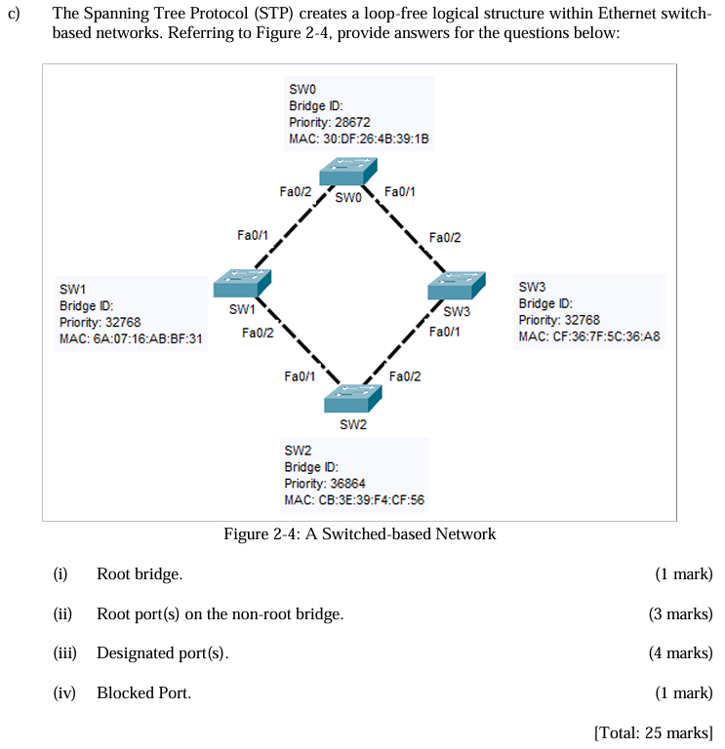
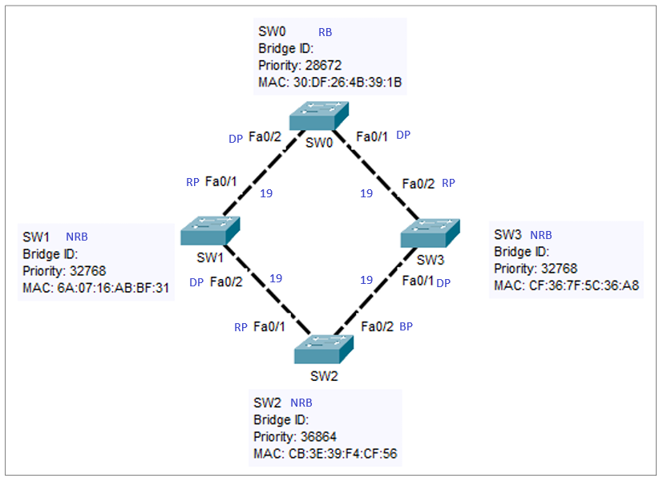
(i) SW0

(ii)
- SW1: Fa0/1
- SW2: Fa0/1
- SW3: Fa0/2

(iii)
- SW0: Fa0/1, Fa0/2
- SW1: Fa0/2
- SW3: Fa0/1

(iv) SW2: Fa0/2

Question 3

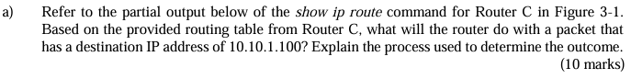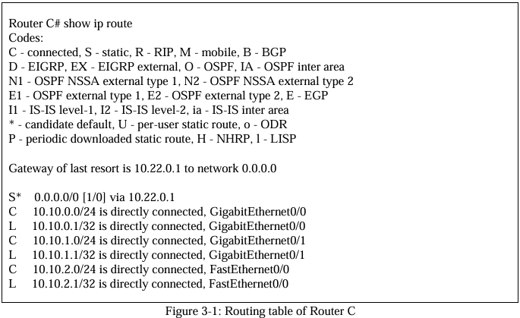
- When the packet reaches Router C, the router will identify whether the destination IP address of the packet which is 10.10.1.100 belongs to the network that is directly connected to the router. If yes, it will forward the packet out of the specified interface.
- If the destination IP address does not belong to a directly connected network, Router C will identify whether the destination IP address belongs to a remote network which is not directly connected to the router based on the routing table. The remote network can be learned by the routers via dynamic routing protocol. If yes, the router will encapsulate the frame and forward it out of the respective interface.
- If the destination IP address still does not belong to the remote network, the router will check whether there is a default route configured. Default route can be configured manually as static default route or learnt via dynamic routing protocol. If yes, the frame will be encapsulated and forward out of the exit interface. Else, the packet will be discarded.
- Based on the routing table, the destination IP address of packet 10.10.1.100 belongs to a directly connected network.
- The route 10.10.1.1/24 is directly connected to the Router C. So, the packet will be forwarded out of the interface GigabitEthernet0/1.

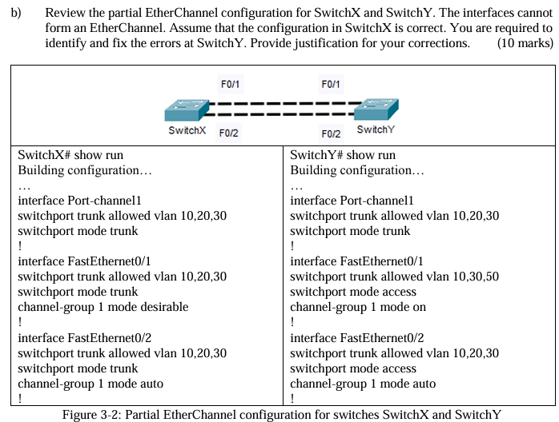
- The VLAN assigned to the interface FastEthernet0/1 on SwitchY does not match with SwitchX.
  - SwitchY interface FastEthernet0/1 should be put into VLAN 10,20 and 30.
interface FastEthernet0/1
no switchport trunk allowed vlan 50
switchport trunk allowed vlan 10,20,30
- The switchport mode of interface FastEthernet0/1 and FastEthernet0/2 on SwitchY is configured wrongly.
  - The switchport mode of SwitchY interface FastEthernet0/1 and FastEthernet0/2 should be configured in trunk mode.
interface range FastEthernet0/1-2
switchport mode trunk
- The channel group 1 in interface FastEthernet0/1 and FastEthernet0/2 on SwitchY are configured wrongly.
  - The channel group 1 mode should be configured in desirable mode.
interface range FastEthernet0/1-2
no channel-group 1 mode auto
channel-group 1 mode desirable

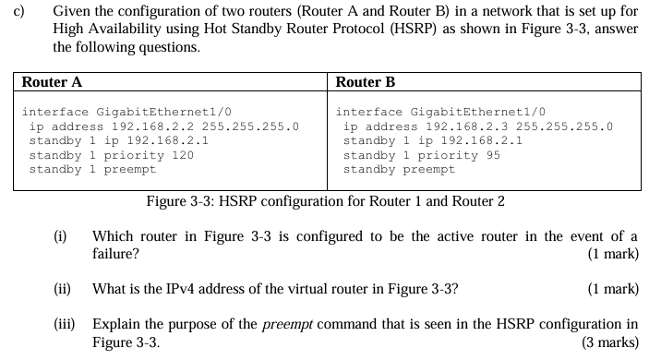
(i) Router B

(ii) 192.168.2.1

(iii)
- When a new router comes online, the preempt command can help in triggering the HSRP re-election process.
- If the new router has the higher HSRP priority, it will be elected as the new active router. Meanwhile, the existing routers with lower HSRP priority will be elected as standby routers.
- If the current active router fails, the re-election process will also be triggered to elect the standby router to assume the roles of new active router for forwarding hello messages.

Question 4

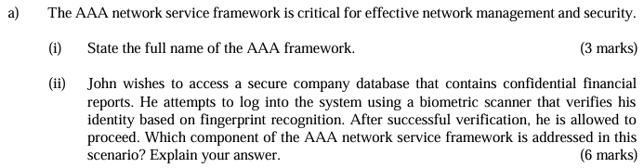
(i) Authentication, Authorization and Accounting framework

(ii)
- Authentication
  - It helps for checking whether John is authenticated for accessing the secure company database based on his fingerprint stored in the database.
- Authorization
  - It helps for identifying John's privileges and restrictions after being authenticated.
  - So, the system will know which actions John can do and cannot do based on a set of attributes.
  - The AAA server will use the set of attributes containing user's access on the system to determine whether John has the permission to access the confidential financial reports.

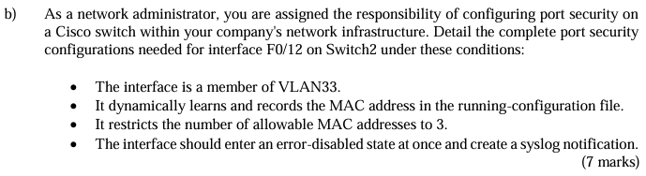
interface f0/12
switchport mode access
switchport access vlan 33
switchport port-security
switchport port-security mac-address sticky
switchport port-security maximum 3
switchport port-security violation shutdown

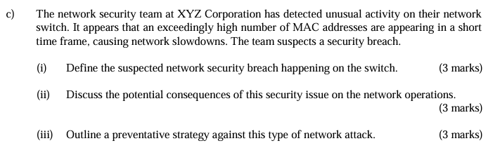
(i)
- The exceedingly high number of MAC addresses appearing in a short time frame may indicate the MAC Table Flooding Attack.
- The attackers bombard the switch with fake MAC addresses to the switch until the MAC table of the switch is full since there is a limited size of MAC table in a switch.

(ii)
- Once the MAC table of switch is full, the switch will treat all the incoming frames as unknown unicast frames and flood them out of all ports in the same VLAN without referencing the MAC table.
- Thus, attackers can capture all the packets sent from one host to another in the local LAN or VLANs.
- The data passed between two parties will be accessed by the attackers.

(iii)
- The port security should be configured on the ports to limit the number of mac addresses being learnt on each port.
- We can set a limit of 3 packets per second on each port using switchport port-security maximum 3 command.

